**Everyday is new Beginning take a deep breath and start again**

**Lahore Garrison**

**University**

**DHA Phase 6 Lahore**



**Student Name**

**Student Roll No**

**Section**

**Subject**

**Web Technology**

**Instructor Name**

**Mr. Muhammad Yousaf**

**Muhammad Saim Ali**

**162**

**D**

**Lab 1: Setting up the Web Development Environment**

# 1. Install a Code Editor

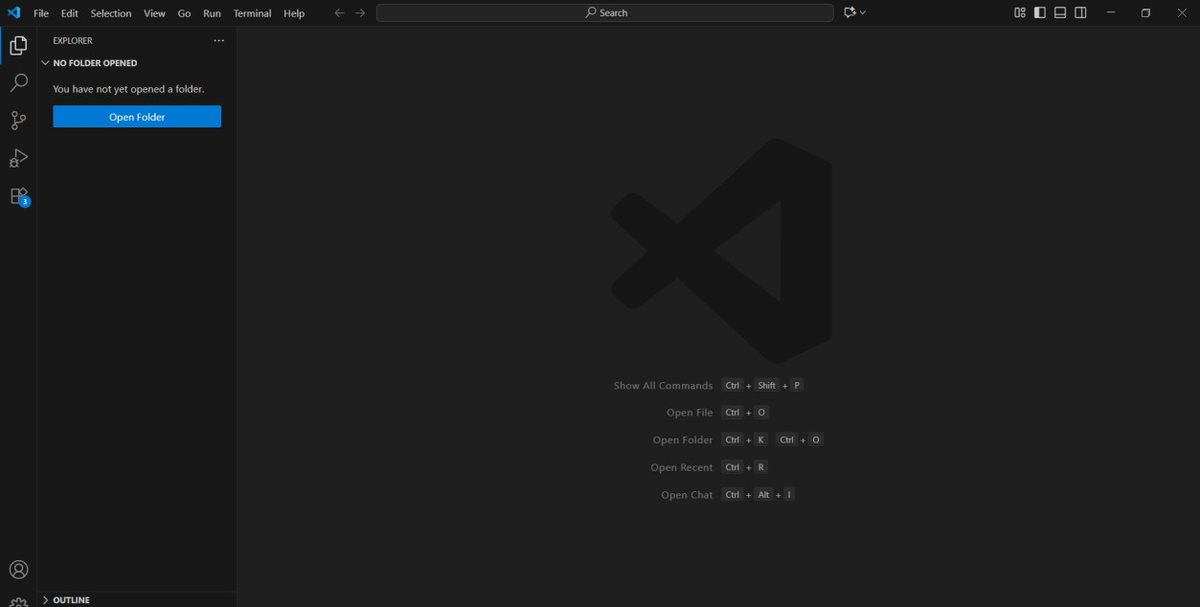

# 2. Install Web Browsers

• I will Prefer Google Chrome

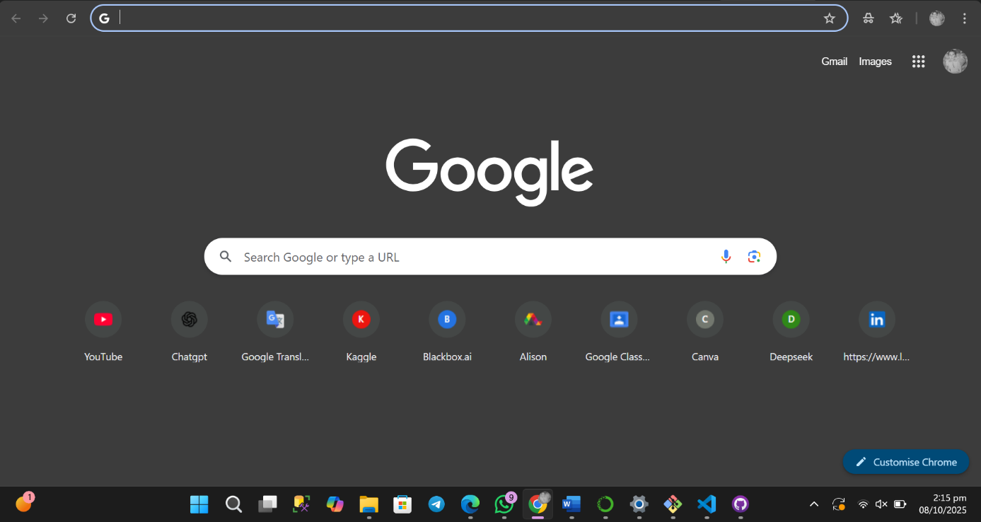

3. Set Up Version Control

* Install Git
* Configure Git with your username and email:
* git config --global user.name "Your Name"
* git config --global user.email “you@example.com”

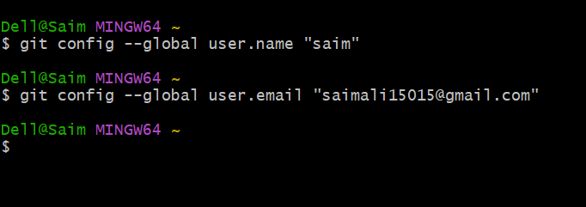

# 4. Create a Project Folder

* Make a folder named *WebDevLab1* on your desktop or preferred location
* Inside, create subfolders: *html, css, js, and assets*

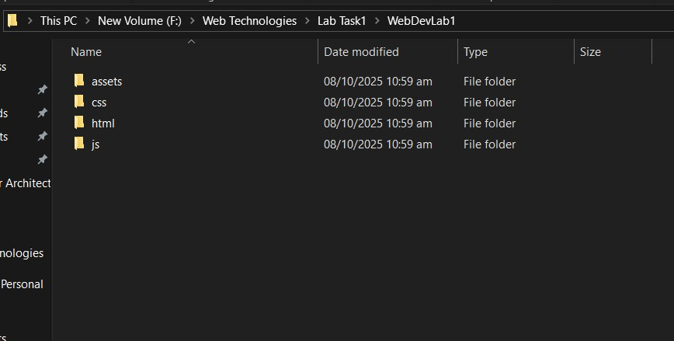

5. Initialize Git Repository

* Open the folder in VS Code • Run:
* git init

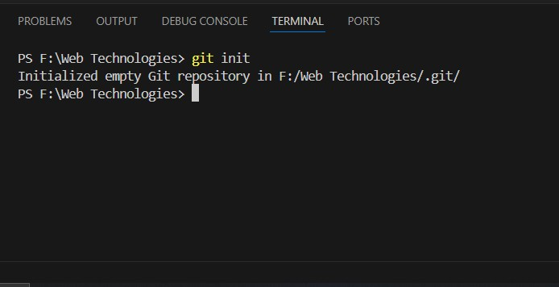

# 6. Install Live Server

* In VS Code, go to Extensions → Search for “Live Server” → Click Install

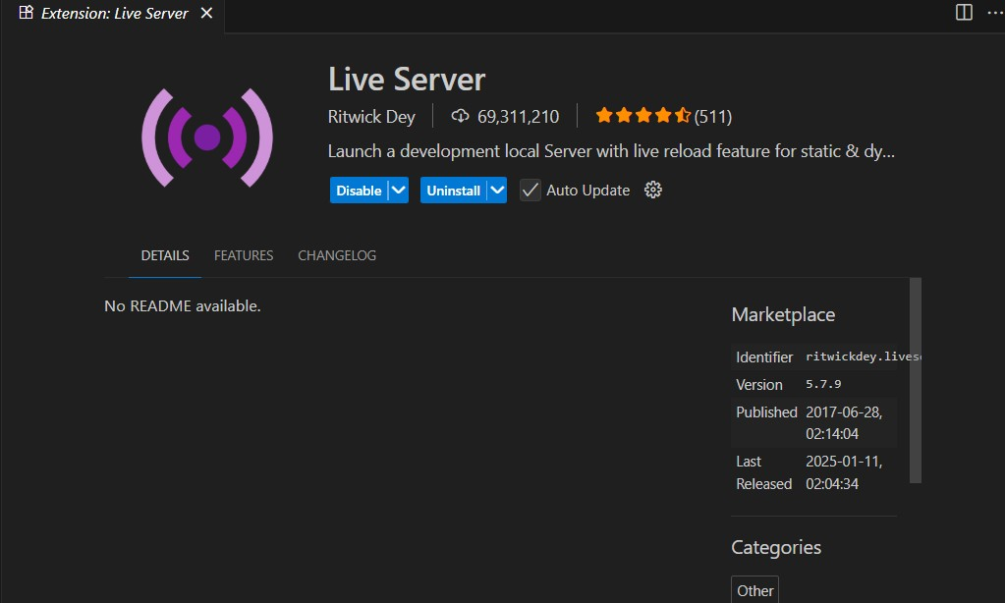

* Right-click your index.html file → “Open with Live Server”

